PAGE TEMPLATE DESIGN
Website: The Art of Interior Design
Wireframes
Homepage wireframe
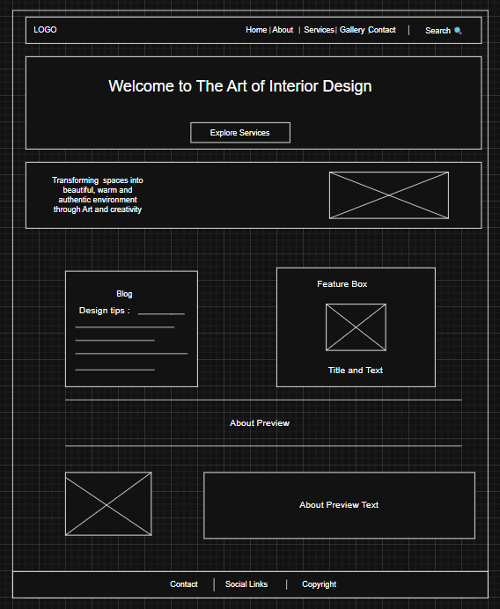
About wireframe
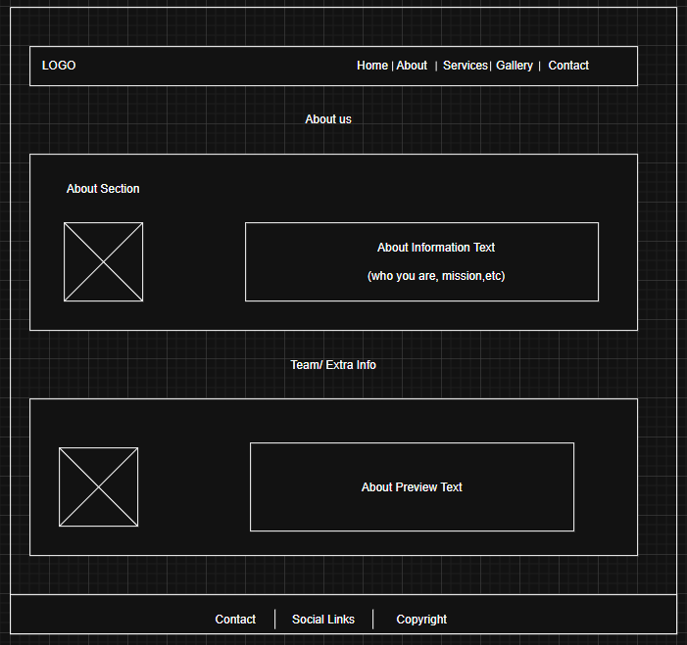

Service wireframe
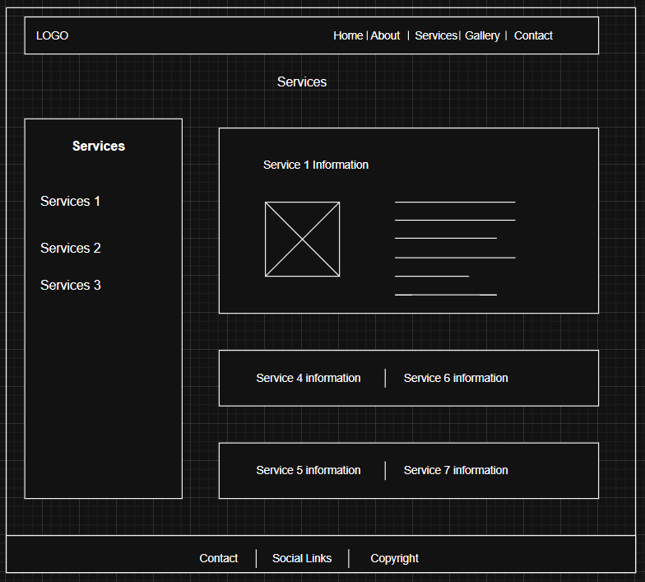

Gallery wireframe

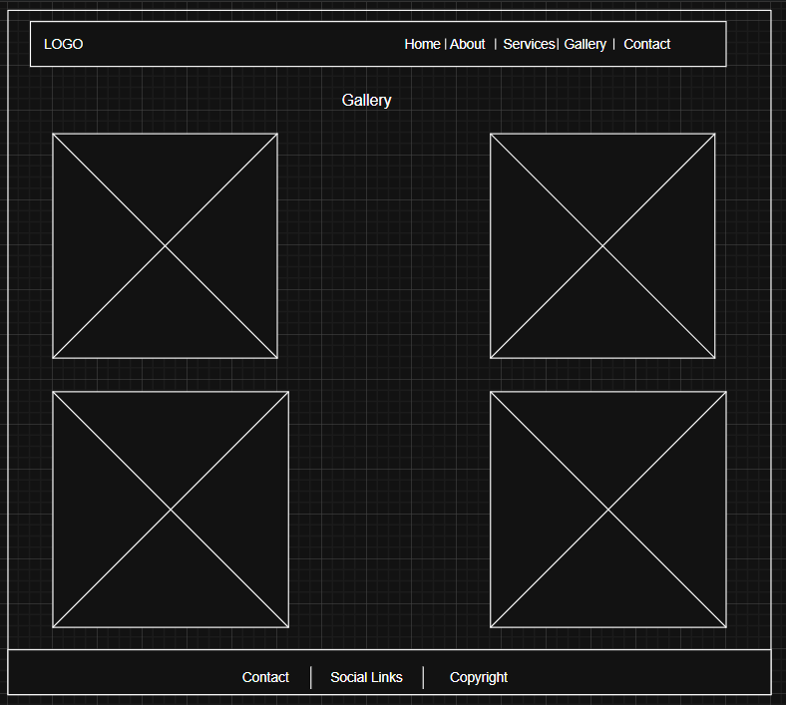

Contact wireframe

